Internal Sources

Definition
# Source: AI Source: Provided by: [Data Path: Persons Table -> ID Column: 1, Name_En Column: Motasem Essam] -> From: [Chatgpt (GPT‑5 Mini)] on [12/10/2025]
Internal sources of data are sources of data that come from within an organization or system.
They are generated as part of the organization’s daily operations and activities.
Key idea:
The data is created, collected, and stored inside the organization.

Common Sources of Internal Data

1️⃣ Sales Records
# Source: AI Source: Provided by: [Data Path: Persons Table -> ID Column: 1, Name_En Column: Motasem Essam] -> From: [Chatgpt (GPT‑5 Mini)] on [12/10/2025]
Definition:
Data about products sold, quantity, price, and revenue.
Example:
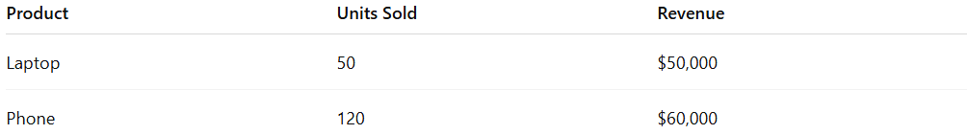
Product | Units Sold | Revenue
Laptop | 50 | $50,000
Phone | 120 | $60,000

2️⃣ Employee Records
# Source: AI Source: Provided by: [Data Path: Persons Table -> ID Column: 1, Name_En Column: Motasem Essam] -> From: [Chatgpt (GPT‑5 Mini)] on [12/10/2025]
Definition:
Information about employees such as name, position, salary, and performance.
Example:
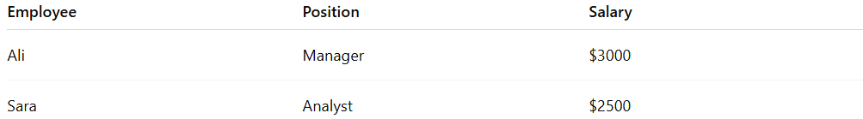
Employee | Position | Salary
Ali | Manager | $3000
Sara | Analyst | $2500

3️⃣ Customer Databases
# Source: AI Source: Provided by: [Data Path: Persons Table -> ID Column: 1, Name_En Column: Motasem Essam] -> From: [Chatgpt (GPT‑5 Mini)] on [12/10/2025]
Definition:
Information about customers such as contact details, purchase history, and preferences.
Example:
Customer | Email | Last Purchase
Omar | omar@email.com | Laptop

4️⃣ Inventory Records
# Source: AI Source: Provided by: [Data Path: Persons Table -> ID Column: 1, Name_En Column: Motasem Essam] -> From: [Chatgpt (GPT‑5 Mini)] on [12/10/2025]
Definition:
Data about stock levels, product availability, and supply.
Example:
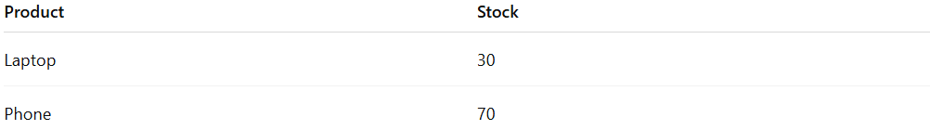
Product | Stock
Laptop | 30
Phone | 70

5️⃣ Financial Records
# Source: AI Source: Provided by: [Data Path: Persons Table -> ID Column: 1, Name_En Column: Motasem Essam] -> From: [Chatgpt (GPT‑5 Mini)] on [12/10/2025]
Definition:
Data related to company finances like expenses, profits, and budgets.
Example:
Month | Expenses | Profit
Jan | $20,000 | $15,000

Example
# Source: AI Source: Provided by: [Data Path: Persons Table -> ID Column: 1, Name_En Column: Motasem Essam] -> From: [Chatgpt (GPT‑5 Mini)] on [12/10/2025]
A store owner wants to analyze business performance.
Instead of collecting information from outside sources, the owner uses internal company records such as sales reports and inventory data.
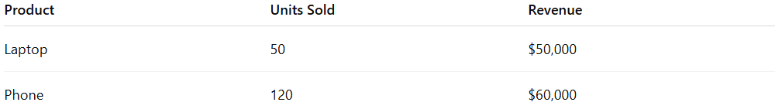
Product | Units Sold | Revenue
Laptop | 50 | $50,000
Phone | 120 | $60,000
Because the data comes from inside the company, it is internal data.

Key Characteristics
# Source: AI Source: Provided by: [Data Path: Persons Table -> ID Column: 1, Name_En Column: Motasem Essam] -> From: [Chatgpt (GPT‑5 Mini)] on [12/10/2025]
- Comes from inside the organization
- Usually easily accessible
- Often accurate and relevant to business operations

✅ Summary
# Source: AI Source: Provided by: [Data Path: Persons Table -> ID Column: 1, Name_En Column: Motasem Essam] -> From: [Chatgpt (GPT‑5 Mini)] on [12/10/2025]

Feature | Internal Data
Source | Inside the organization
Examples | Sales records, employee data, inventory
Purpose | Help manage operations and decisions

